**Using AEV and AFS federated content in ADP**

By default, ADP comes with the [AEVT (formerly OAT)](https://docs.alfresco.com/enterprise-viewer/latest/install/aevt/) enabled. When trying to display remote content PDF files, the OAT modules are failing. In discussions with George Steimer & team (James Harkins & Dan Grumieaux), they were surprised the ADP images were using OAT and recommended disabling it.

To successfully disable the default AEVT/OAT configuration, there are two required changes to allow AEV to properly display both local and federated (remote) content of types image, rtf, docx, and pdf.

1. In the alfresco-global.properties file (in adp/data/services/content), change the annotation.useContentFilepathForTransformations property to false.  
   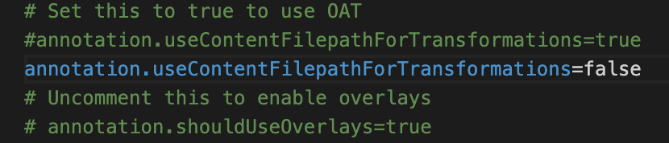
2. In the nginx.conf (in adp/data/services/nginx) comment out the stanza for the following location.  
   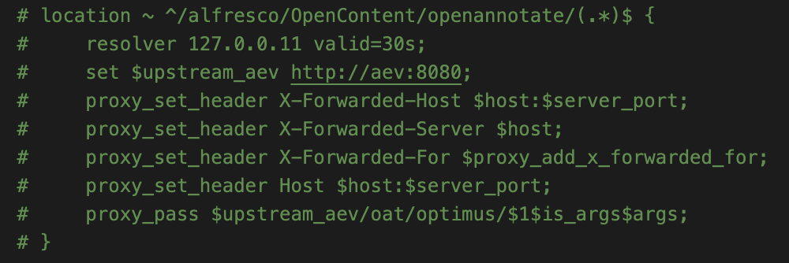

Once the changes are saved, recycle the content and nginx services.

*Internal documentation links from George.*

<https://hyland.atlassian.net/wiki/spaces/SESS/pages/375855378/What+is+AEVT+OAT+and+when+do+I+want+to+use+it>

[**What is AEVT/OAT and when do I want to use it?**](https://hyland.atlassian.net/wiki/spaces/SESS/pages/375855378?atlOrigin=eyJpIjoiNTRmMTdkZTFhOWY3NDRhZWIxMWJhNWY2NGJkNjZmZTciLCJwIjoiY29uZmx1ZW5jZS1jaGF0cy1pbnQifQ) in [**Services Engineering**](https://hyland.atlassian.net/wiki/spaces/SESS?atlOrigin=eyJpIjoiNzUxNzY0ZmUyOWMzNDZiN2JkMmI0N2YzZjZjNWZjZjEiLCJwIjoiY29uZmx1ZW5jZS1jaGF0cy1pbnQifQ)